### Homework 7

1. Product Quality:
   1. Calculate overall number of defects by priority and status for current project release using excel pivot table or jira dashboard, if project uses jira
   2. Build Created vs Resolved trend chart
   3. Based on collected metrics make conclusions about current product quality and your projections about product quality before delivery, provide recommendations
2. Test Status
   1. Build test status by user stories/epics for current release
   2. Build burndown chart
   3. Based on collected metrics make conclusion about current progress and possibility to meet deadline, provide recommendations

1.1.

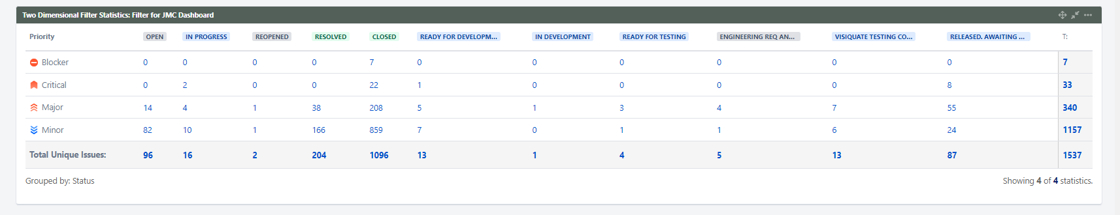

1.2. 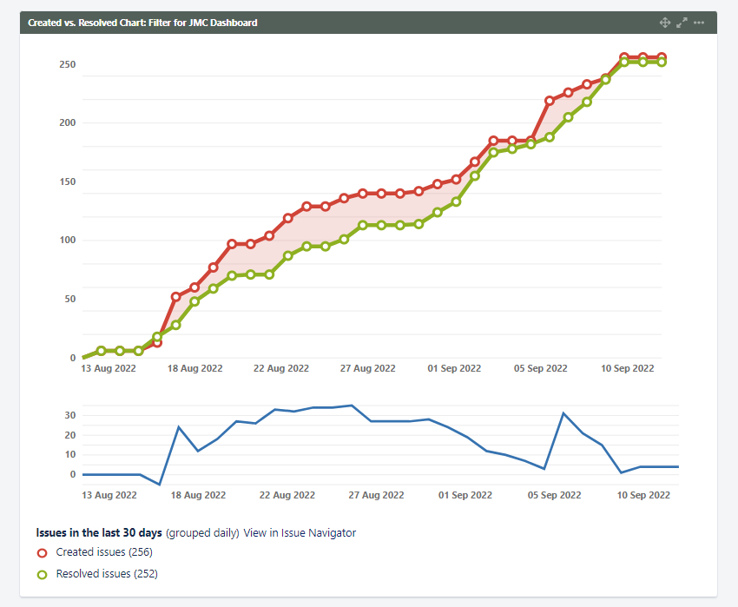

1.3. Since we offer similar solutions for our clients, we rarely encounter critical bugs during development that could not have been avoided. The chart 1.1 shows that most of the bugs are minor, which is a good indicator for the product. The chart 1.2 shows that the difference between open and resolved issues is very small (256/252), but it is clear that this indicator is not uniform throughout the timeline and at some stages the performance was worse than usual. It is possible to investigate such stages.

2.1.

| **Item** | **Requirements** | **Development** | **TC's Creation** | **Testing Status** |
| --- | --- | --- | --- | --- |
| PROD deploy | **Done** | **In Progress** | **Done** | **Not Started** |
| correct typo in Process Family column | **Done** | **Done** | **Done** | **Tested** |
| Clarification on Directors hierarchy visibility | **In Progress** | **In Progress** | **Not Started** | **In Progress** |
| Include just HB records for now | **Done** | **Done** | **Done** | **Tested** |
| Auto-status is working incorrectly | **Done** | **Done** | **Done** | **Tested** |
| Flo Segment' logic is incorrect | **Done** | **In Progress** | **Done** | **Not Started** |
| Update the Standard assignee handling in FLO | **Done** | **Done** | **Done** | **Tested** |

2.2.

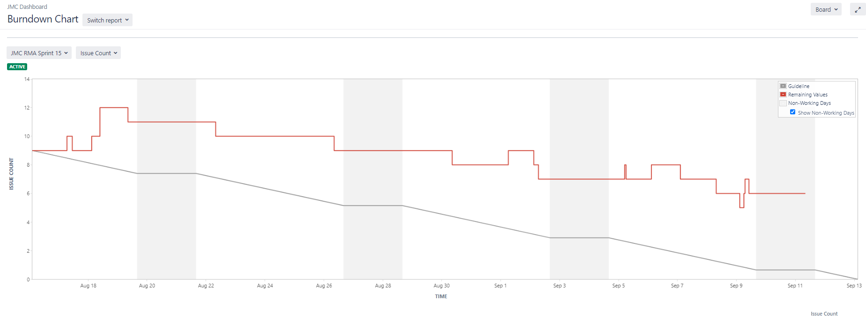

2.3.

Table 2.1 shows that most of the tasks to be released are ready. Since the table was completed 4 days before the release, the remaining tasks are likely to be done and the release will go as planned. The chart 2.2 shows that the development process is going as planned. It can be seen that at the beginning of the month there were a lot of tasks to work with. But in general, the Remaining values line is going down almost like a Guideline.